Setup rbenv / Ruby on MacOS

If you have a modern version of Ruby (>2.4) installed on your machine, feel free to skip this lesson.

If you do not know if Ruby is installed, open your Terminal and execute ​ruby -v​. A successful installation of Ruby should return a valid version number (such as 2.5.1 below).



It is **OK** to proceed through the course with a more modern version of Ruby (such as 2.6, which was released in December 2018).

**If Ruby is not installed...**

I recommend using the version manager **rbenv**to install Ruby. It allows for *multiple* versions of the language to be installed on the same computer — this is beneficial when you have codebases that each use a different version of Ruby.

To install **rbenv**, I recommend using the **Homebrew** package manager for Mac. It is a piece of software that simplifies the process of installing and configuring other pieces of software for your computer.

Here’s the complete set of instructions:

* Navigate to <https://brew.sh/>. Copy and execute the installation script at the top of the page in your Terminal. It's the one that begins with /usr/bin/ruby -e



* Execute ​brew update​ to update Homebrew's available formulas (the software that's available to download).



* Execute ​brew install rbenv​ to install the **rbenv** Ruby version manager.



* Execute ​rbenv init​. It will output the final step for completing installation: opening the ~/.bash_profile file in your code editor and pasting / saving the eval "$(rbenv init -)" line inside it.

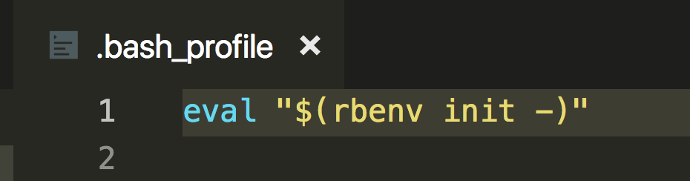

* Execute the rbenv command. If you use a list of commands, the program is successfully installed.

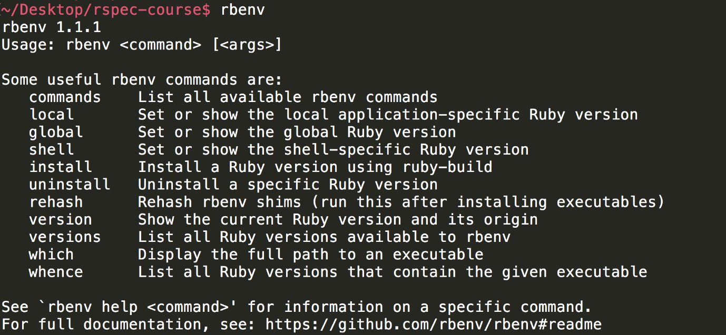

* Execute ​rbenv install 2.5.1​ to install Ruby 2.5.1.
* Execute ​rbenv global 2.5.1 to set the 2.5.1 installation as the system default.
* Execute rbenv version to confirm 2.5.1 appears.



Resources for this lecture

* Homebrew Package Manager Website - https://brew.sh/
* GitHub repo for the rbenv Ruby version manager - https://github.com/rbenv/rbenv